gui design implementation, gui testing, complexity measures

**What is the process of ux?**

Ux has 3 key phases: discover, ideation, and validation. However, ux design is cyclical and you will need to repeat certain steps and even the entire process multiple times.

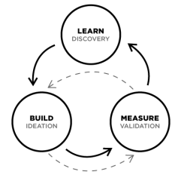

The final outcome will be a set of low-resolution wireframes: a draft of the function and structure of a product.

1. Discover: UX always starts with discovery. Interviewing potential customers to understand what the targete audience need and talking to stakeholders to understasnd their goals and competitive analysis. Discovery is all about WHY - xxx. During discovery, you will validate your problem (your product is there to solve that problem), identify your end users, and determine project goals

Methods:

* User research (interviews, ethnography
* Empathy mapping
* Task analysis
* Stakeholder mapping
* Service blueprints
* Analytics and heuristics
* Competitive analysis

Outcome: problem validation, user personas, project Goals

1. Ideate: next come ideation - using a variety of tools to imagine a solution that solves the user problem, while aligning with the company goals within technological possibility. Ideation is the process of finding out HOW. How ill you create a solution that solves the users deepest needs in a delightful manner? Designers will implement a variety of tools sto figure out how to solve the user problems. This process is very much like a funnel, where the solution is very wide at the beginning, and the goal of the process is to quickly, envision and test products with targete customers in order to pivot and define. During ideation, you will organize your discovery, explore options and develop wireframes and prototypes.

Methods:

* Sketching
* Wireframes
* Information architecture
* Journey mapping / page flows
* User journey writing
* Paper prototypes
* Interaction design

Outcome: solution exploration

1. Validate (test, prototype): the ux process ends with validation - the testing of wireframes and prototypes to iterate on the interface until it is intuitive and delightful. Validation is when we finally know WHAT we are building. During this phase, designers will create wireframes or prototypes, and test them with users during a process called usability testing to evaluate how an actual user will react to the product. The designer observes, asks open-ended questions and iterates on the wireframe based on this feedback. Validation testing is giving those wireframes or prototypes to real users.

You are tracking actual interactions with the prototype here as well as confirming previously held assumptions. The results of validation testing should be changes in flow and layout, though likely not scope anymore. During validadtion, you will validate your ideas, learn, and plan for the next iteration.

Methods:

* Accessibility
* Usability testing
* Feedback integration
* Interactive design
* Retrospectives
* Release

Outcome: solution scalability, low-res wireframes

**What is the process of UI?**

Ux has key phases: desgin and testing. UI design precedes the development of the product’s functional elements.

UI design is the creation of the finished interface; its focus is on the visual and emotional feel of the product. UI design establishes the layout, colors, typography and interactivity to visually communicate the flow of thee screens in an intuitive manner. The UI design process must balance technical functionality and visual elements to create a system that is not only operational but also usable and adaptable to changing user needs.

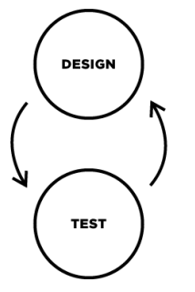

1. Design: after ideation is design - this puts your ideas to the test. During design, you will commit to internally validated ideas and test those ideas with uses. After you complete the design process, you will likeely bring what you have learned back to step 2 (ideation) and repeat this step again. This can happen multiple times

Methods:

* Design sprints
* Style guides

1. Validate (test, prototype): after you design, you willl test to validate your design ideas. During testing, you will test your ideas with uses. After you complete the testing process, you will likely bring what you have learned bact to step 1 (design) and repeat this step again. This can happen multiple times

How do UI and UX fit together

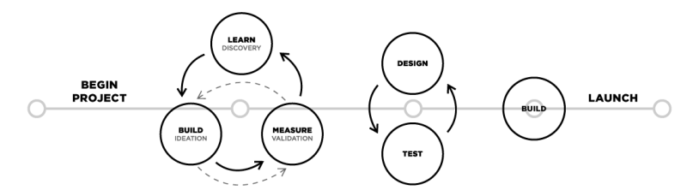

The processes of UX design and UI design are flexible and there is no “right” way of bringing them together for one project. Typically, a project will need UX design first and then UI design. However, for existing products, either process may be used alone to improve either UX or UI.

Practical Applications and Design Thinking

UX and UI are driven by Design thinking, which refers to creative strategies designers use during the process of designing. This approach is also useful to resolve issues outside of professional design practice, such as in business, social or personal contexts.

There are 5 keys to design thinking, and you can apply them to your everyday life

1. Empathize: when you design, you are not primarily doing it for yourself. You are doing it with other people’s needs and desires in mind. Focus on the person or problem that you are serving. Find ways to serve them better. Help their lovers to be better each day. Empathize first
2. Discover: try to narrow down your problem to the root cause. Jump in with an open mind, without criticism or opinions. Seek to understand before you are understood.
3. Ideate: be imaginative, create ideas to solve the problem you identified instep 2
4. Prototype: place the concept of being perfect aside. Embrace failurer to master the process. Don’t be cautious
5. Test: cultivate self-awareness by asking yourself, “what do I really want to see or experience?” Never limit yourself

Assignment

Part 1:

1. What is:
2. User research (interviews, ethnography
3. Empathy mapping
4. Task analysis
5. Stakeholder mapping
6. Service blueprints
7. Analytics and heuristics
8. Competitive analysis
9. What is:
10. Sketching
11. Wireframes
12. Information architecture
13. Journey mapping / page flows
14. User journey writing
15. Paper prototypes
16. Interaction design

Part 2: